**Assisted Practice: 3.12 Delete an S3 Bucket**

This section will guide you to:

* Delete an S3 bucket

This lab has three subsections, namely:

3.12.1 Selecting the S3 bucket you want to delete

3.12.2 Deleting the bucket

3.12.3 Pushing the files to GitHub repositories

**Step 3.12.1:** Selecting the S3 bucket you want to delete

* Choose the bucket

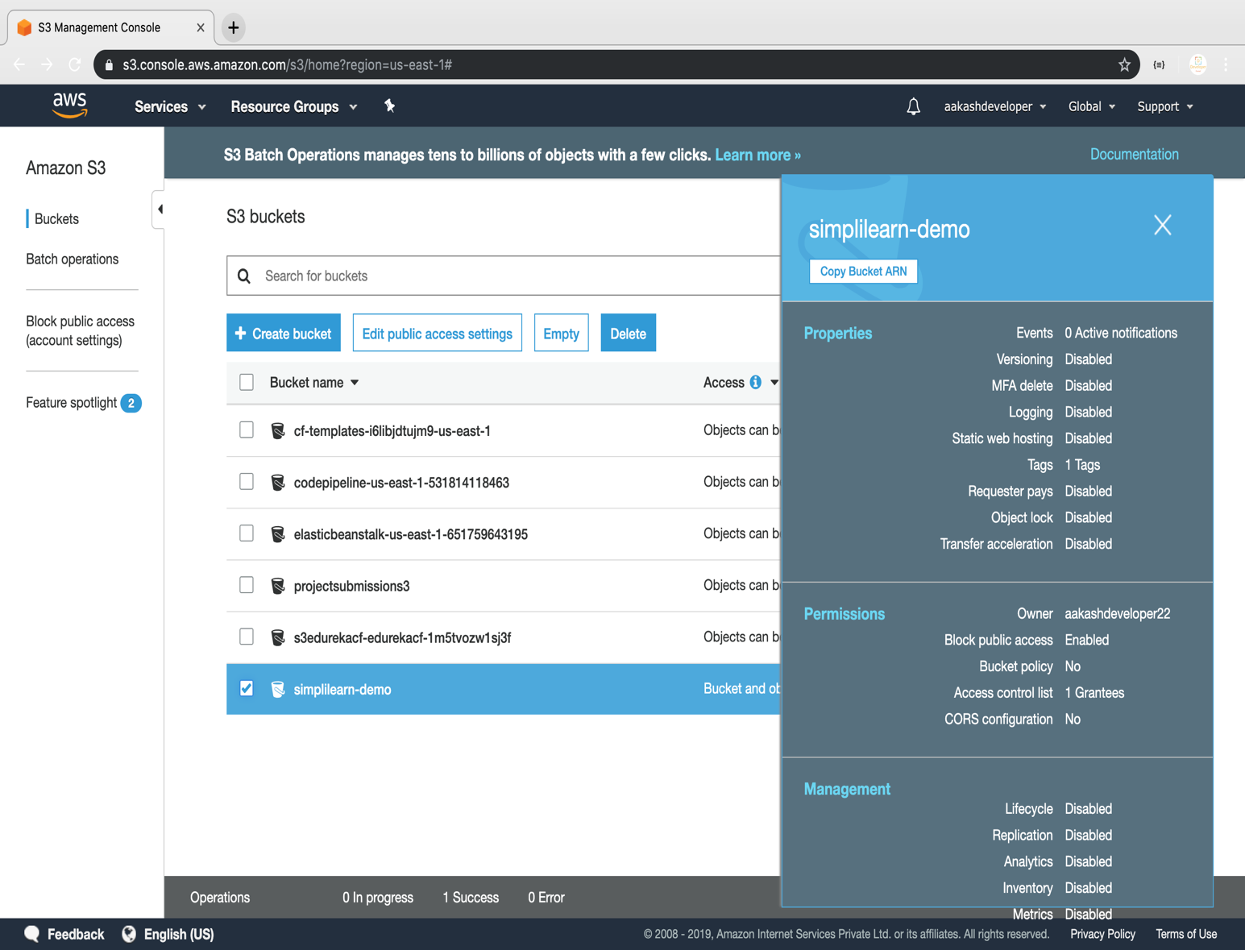

**Step 3.12.2:** Deleting the bucket

